DIGITAL MARKETING ASSIGNMENT

|  |  |
| --- | --- |
| Name | Thinisha.T |
| Reg. No | 960220106105 |
| NM ID | 610C965EDE93EBF9B1A4606563F445F0 |
| Team ID | NM2023TMID09736 |

1.Create a blog or website using Blogspot and WordPress. Customize the theme design and post new article with 500 words.

Blog links:

Blogger: <https://dreamfashion16.blogspot.com/2023/08/a-captivating-and-ever-evolving-realm.html>

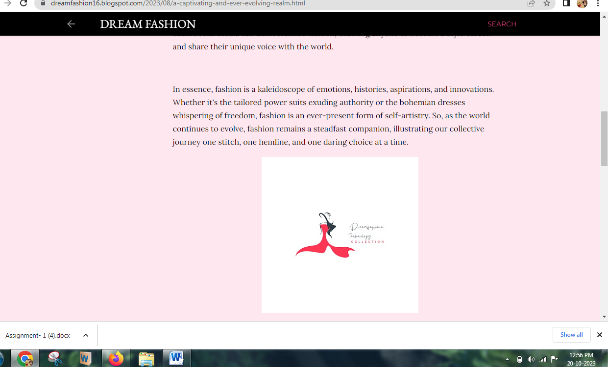

Word Press: <https://ffgg3.wordpress.com/2023/10/06/dream-fashion/>

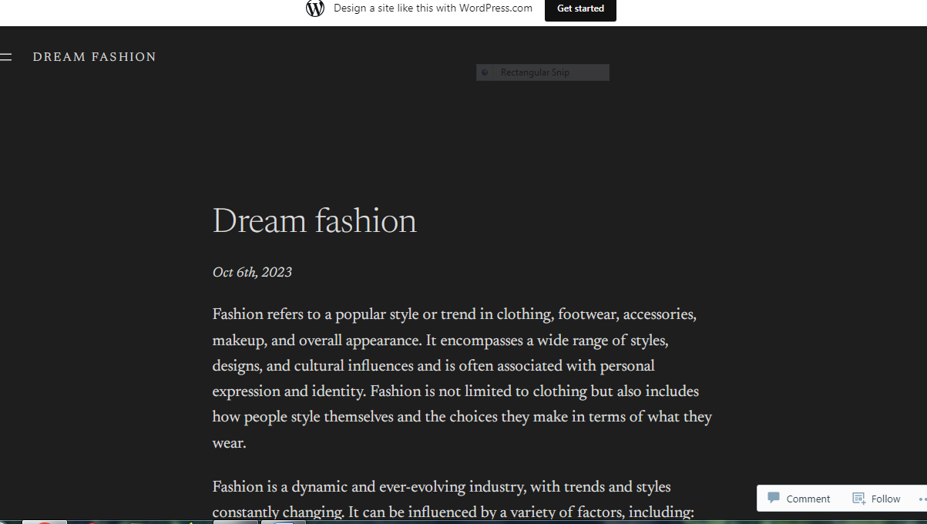

**2.Create a New Facebook Business Page and post one social media poster for your brand.**

Facebook Business page Link : <https://m.facebook.com/story.php?story_fbid=122111386760003127&id=61550093829480&mibextid=Nif5oz>

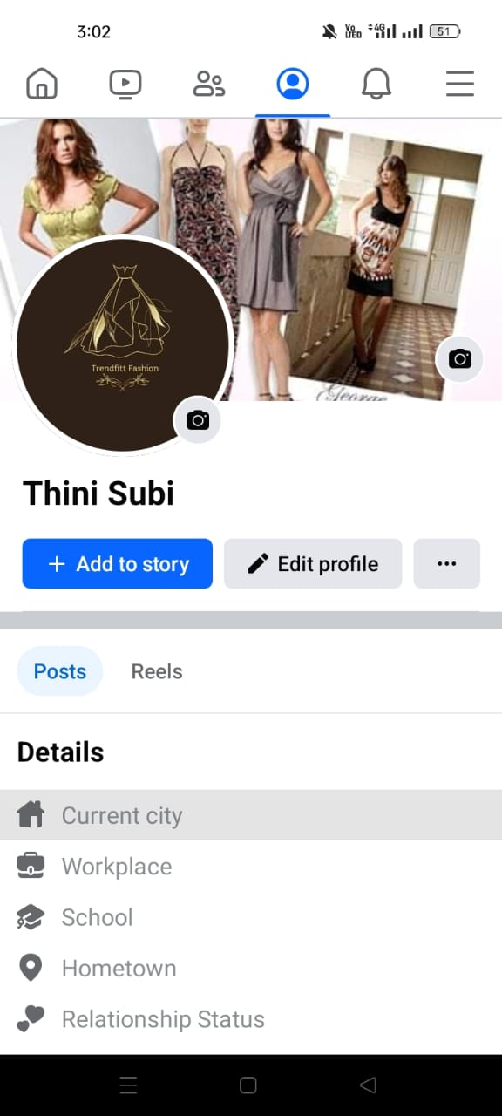



**3.Create and design a social media advertisement poster using canva.**

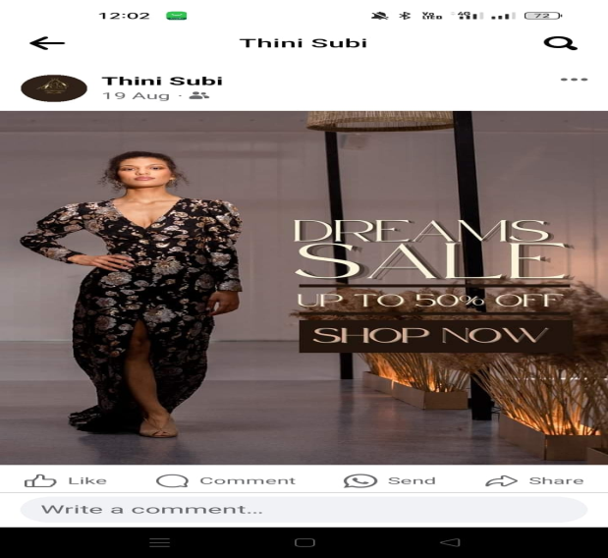

4.Create email newsletter design using MailChimp or canva

tool

Email

Newsletter link: <https://dreamfashion16.blogspot.com/2023/09/dream-fashion.html>

